MOONS - Constrained Transport (CT) Discretization

One can equally regard a collocated $B$ (cell centered) as the primary variable and eliminate $b$ (face centered) from the CT schemes altogether, which simplifies the implementation (no need for staggered variables), the interpretation in the finite volume sense, and comparison with other schemes [1].

The magnetic field is updated through Faraday's Law:

$$B_{j,k}^{x,n+1}=B_{j,k}^{x,n}-Δt\frac{{\overline{f}}_{j,k+\frac{1}{2}}^{y}-{\overline{f}}_{j,k-\frac{1}{2}}^{y}}{Δy}$$

$$B_{j,k}^{y,n+1}=B_{j,k}^{y,n}-Δt\frac{{\overline{f}}_{j+\frac{1}{2},k}^{x}-{\overline{f}}_{j-\frac{1}{2},k}^{x}}{Δx}$$

Where the new numerical fluxes are defined as

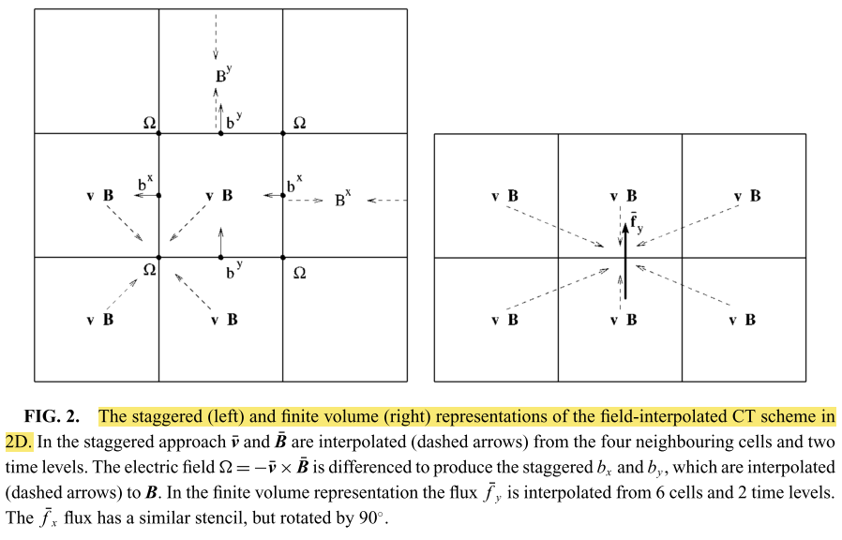

1. "Tóth, G. The divergence Constraint in Shock-Capturing MHD Codes. *J. Comput. Phys.* **161,** 605–652 (2000)."